**HIVE Data Definition Language**

**Hive Data Definition** Language (DDL) is a subset of **Hive** SQL statements that describe the **data** structure in **Hive** by creating, deleting, or altering schema objects such as databases, tables, views, partitions, and buckets. ... The comments in **Hive** start from –

**Create Database in Hive**

As the name implies, this DDL command in Hive is used for creating databases.

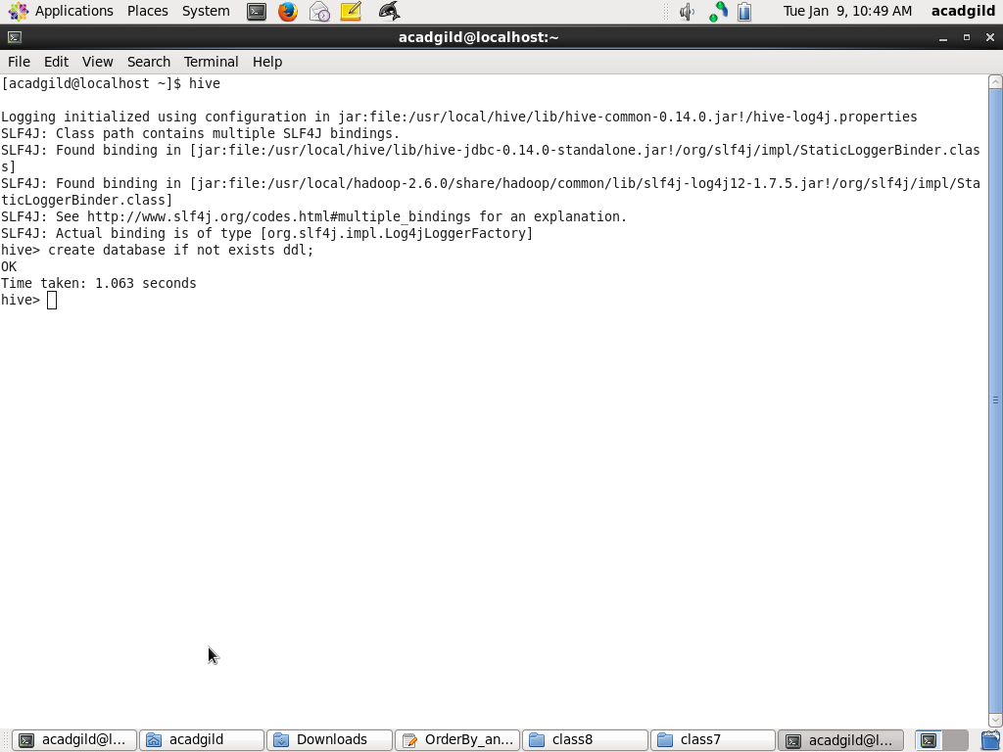

### ****Drop Database in Hive****

This command is used for deleting an already created database in Hive and the syntax is as follows –

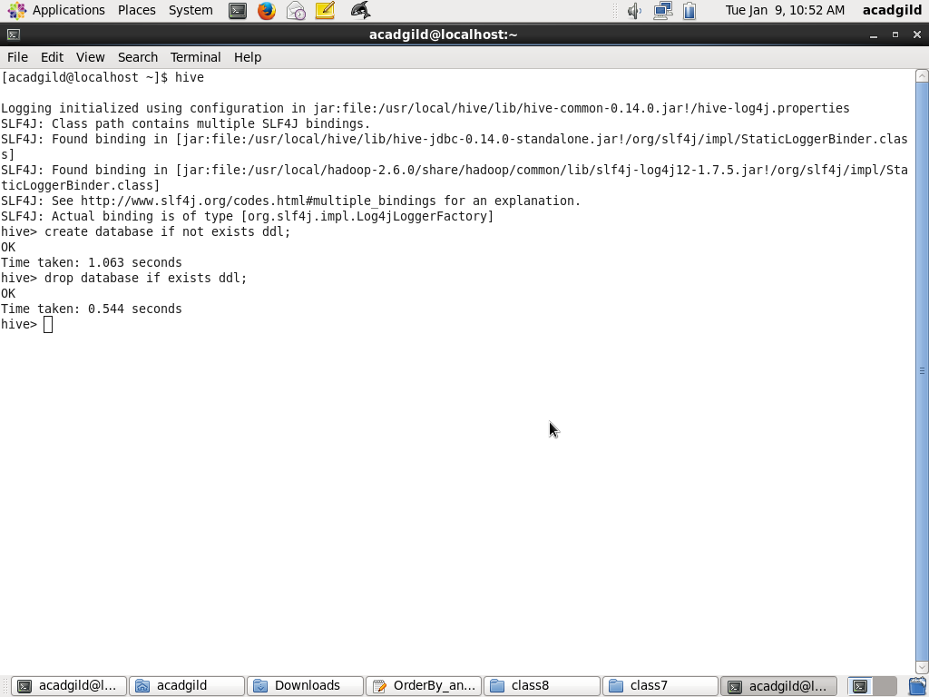

#### **Usage of Drop Database Command in Hive**

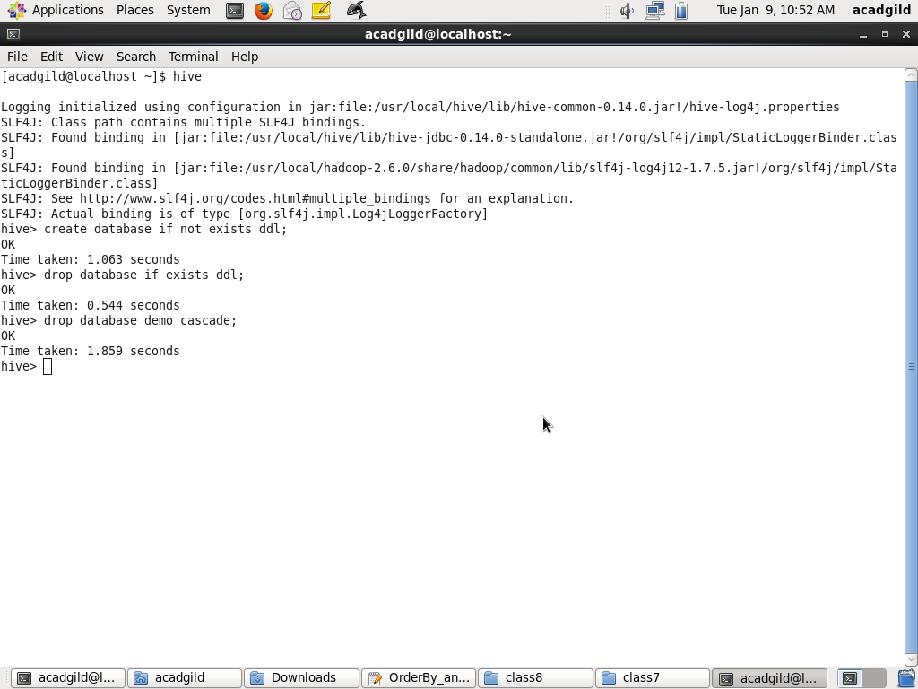

In Hadoop Hive, the mode is set as RESTRICT by default and users cannot delete it unless it is non-empty. For deleting a database in Hive along with the existing tables, users must change the mode from RESTRICT to CASCADE.

In the syntax for drop database Hive command, “if exists” clause is used to avoid any errors that might occur if the programmer tries to delete a database which does not exist.

### ****Describe Database Command in Hive****

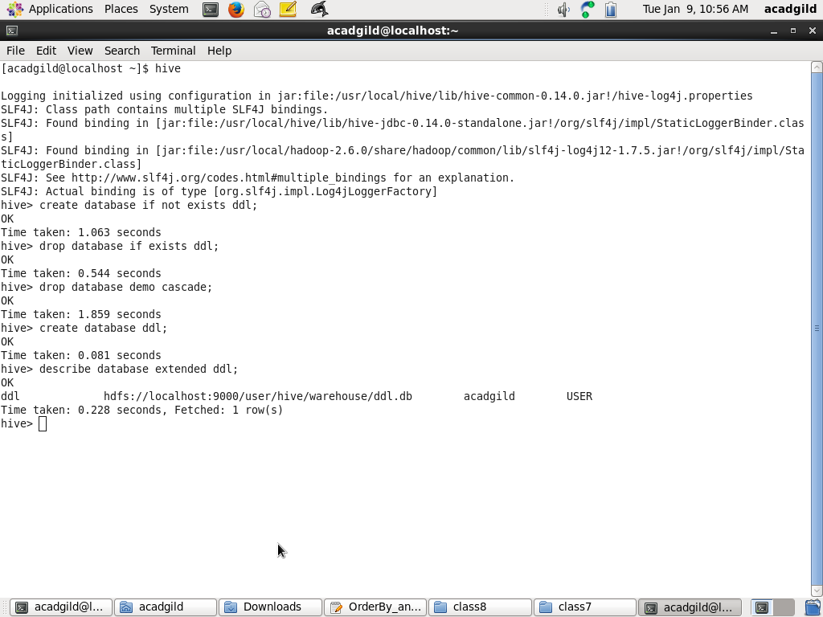

This command is used to check any associated metadata for the databases.

**Usage of ALTER database command in Hive –**

Let’s use the Alter command to modify the OWNER property and specify the role for the owner –

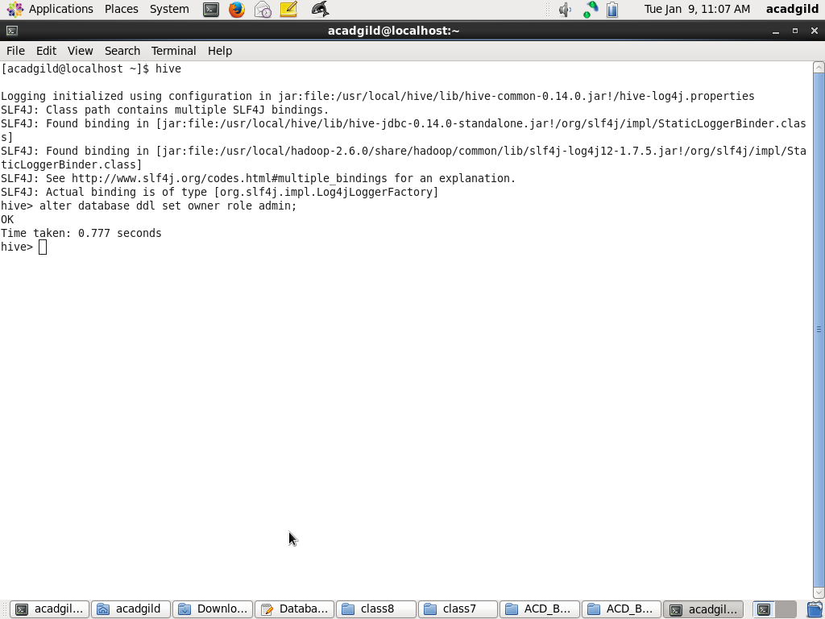

### ****Show Database Command in Hive****

Programmers can view the list of existing databases in the current schema.

#### **Usage of Show Database Command**

Show databases;

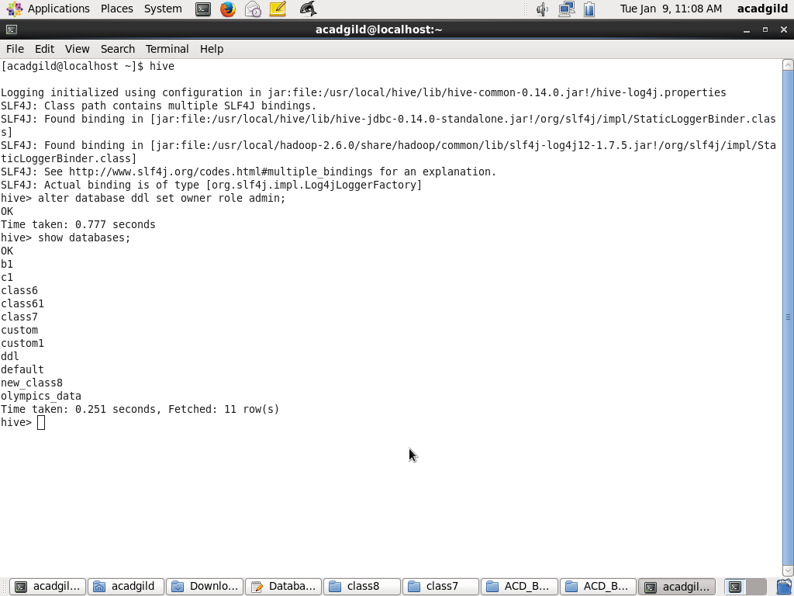

### ****Use Database Command in Hive****

This hive command is used to select a specific database for the session on which hive queries would be executed.

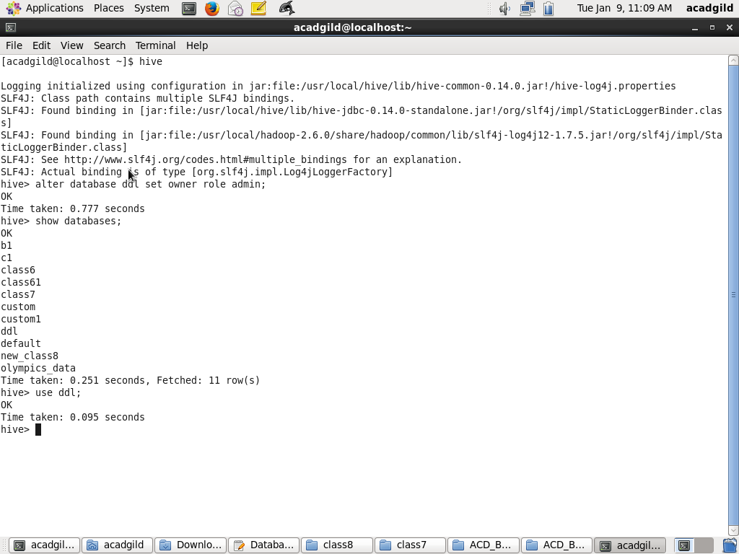

### ****DDL Commands on Tables in Hive****

#### **Create Table Command in Hive**

Hive create table command is used to create a table in the existing database that is in use for a particular session.

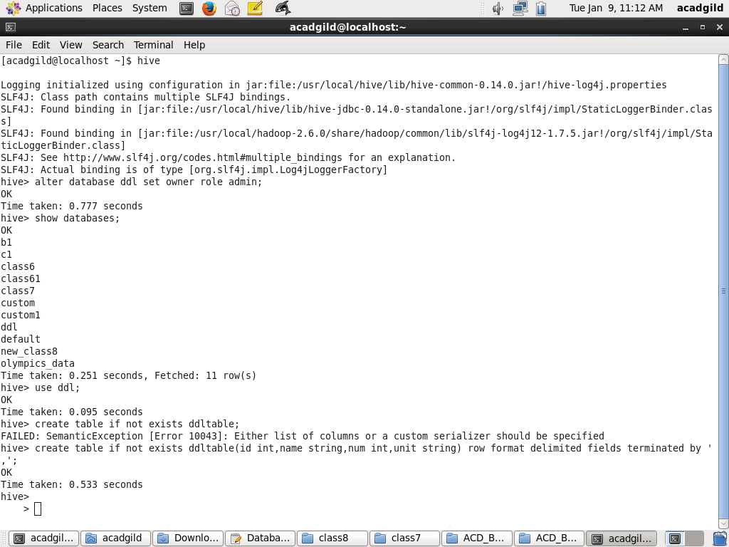

### ****DROP Table Command in Hive****

Drops the table and all the data associated with it in the Hive metastore.

DROP table command removes the metadata and data for a particular table. Data is usually moved to .Trash/Current directory if Trash is configured. If PURGE option is specified then the table data will not go to the trash directory and there will be no scope to retrieve the data in case of erroneous DROP command execution.

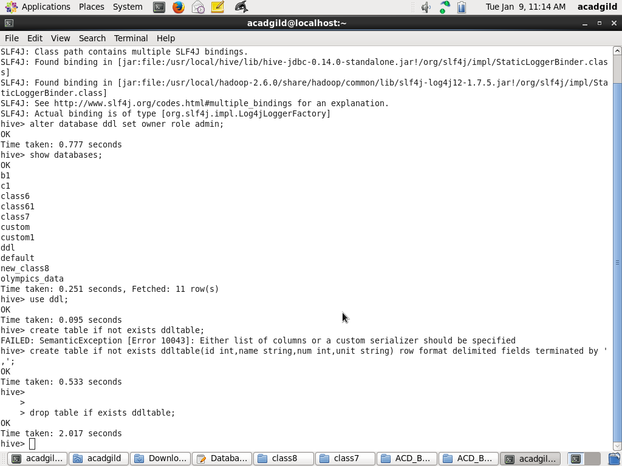

### ****ALTER Table Command in Hive****

Using ALTER Table command, the structure and metadata of the table can be modified even after the table has been created. Let’s try to change the name of an existing table using the ALTER command –

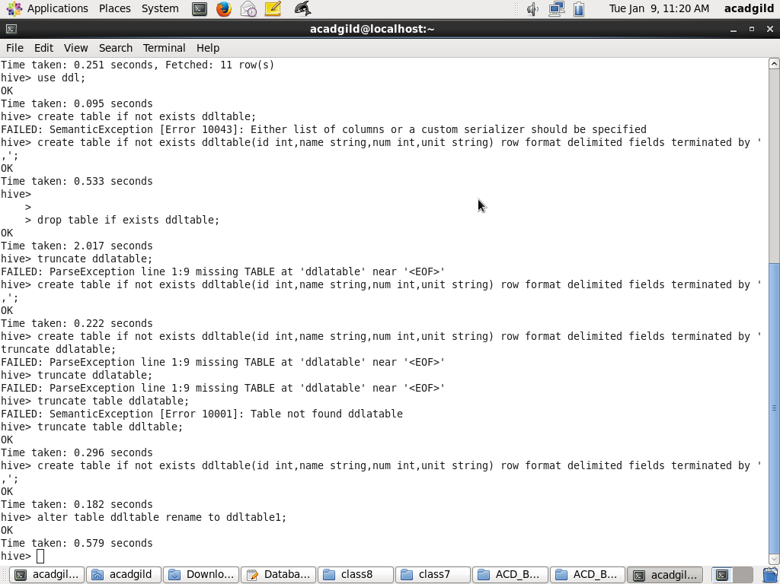

### ****DESCRIBE Table Command in Hive****

Gives the information of a particular table and the syntax is as follows –



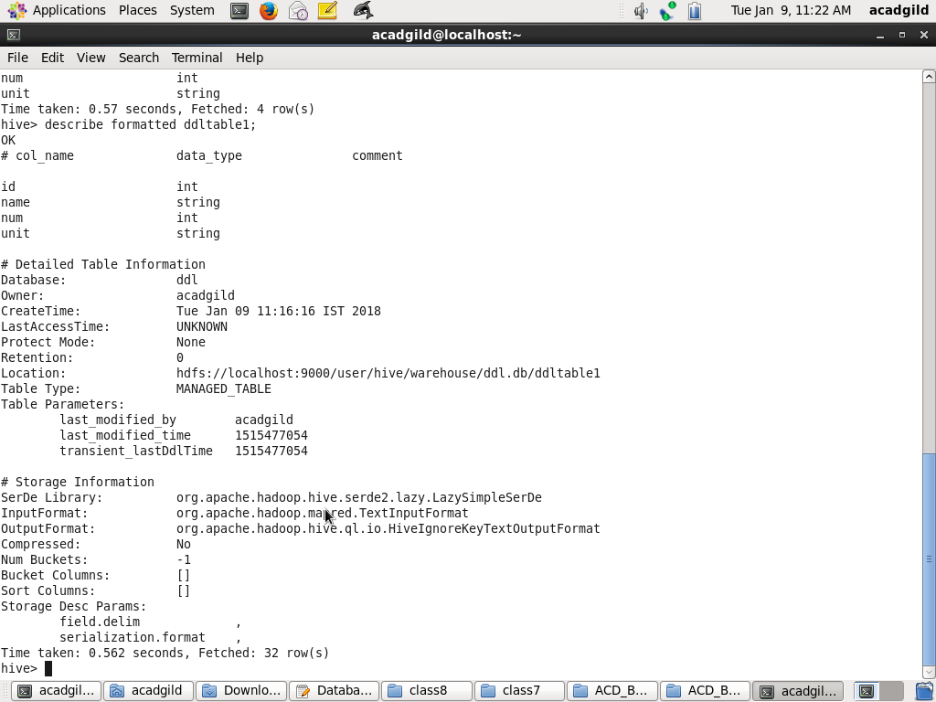

### ****TRUNCATE Table Command in Hive****

 This hive command is used to truncate all the rows present in a table i.e. it deletes all the data from the Hive meta store and the data cannot be restored.

